3.66: (a)
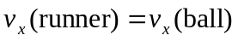
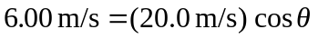
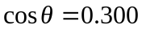
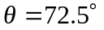

Time the ball is in the air:

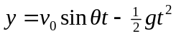
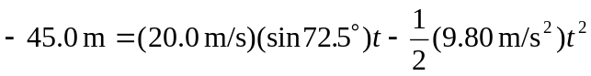

Solve for t: 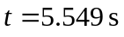.
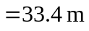

(b)
